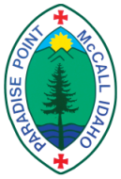
PARADISE POINT SUMMER CAMP
The Episcopal Church in Idaho
McCall, ID

Paradise Point Camp medication intake requirements

Moving toward best practices for medication intake, Paradise Point Camp requires all medications sent to camp (prescription and nonprescription) to be pre-packaged by a pharmacist, parent/guardian, or camp staff.

Camps across the country have seen an increase in the number of campers coming to overnight camps with medications, and an increase in the number of medications to be distributed per camper. To decrease the likelihood of medication errors, Paradise Point Camp will approve only the following pre-packaged medication forms:

Pharmacy packed blister packs
Many pharmacies (Albertsons, CVS) will prepare a week of medication in blister or bubble packs, often at no cost to you. Call your pharmacy and ask them to prepare a week long blister pack for your camper, divided by day and dispensing time. This is the best option, ensuring that your camper gets the correct medication at the right time of day and is simple for the on-site health care provider to confirm all information. Most pharmacies will include non-prescription medications like supplements, vitamins or daily allergy medications while packing prescription blister packs.

Parent/guardian packed blister packs
You can prepare your camper’s medications before camp. Medications need to be in tamper-evident packaging (no ziplocks or reusable pill organizers, please) and separated by day and delivery time. Paradise Point Camp recommends this type of at-home blister packing. You will also need to provide a printed copy of the prescription information (must include camper’s name, delivery information and relevant warnings). Your help pre-packaging blister packs ensures accurate medication delivery, speeds up the check-in process and helps keep our on-site health care provider and staff organized. You may also include non-prescription supplements, vitamins, or daily allergy medications in the blister packs- just be sure to include the information in the printed summary.

Paradise Point Camp medicine packing
For an additional fee of $35, Paradise Point Camp will blister pack medications for your camper at drop-off while you wait. Prescriptions must be brought to camp in their original containers printed with the name of your camper, delivery information and all warnings. Any extra medications will be returned to the parent/guardian at the time the blister pack is filled. Paradise Point Camp will only pack medications for campers at camp, not at any bus stop locations.

The important information for the on-site health care provider to confirm prescription information: camper name, prescription information (must confirm medication is prescribed to the camper and include delivery information), and medication warnings (Ex: Do not eat grapefruit with medication).

Exceptions to the blister pack policy include: Epi-pens, inhalers, drops, liquids or creams, as-needed medication (PRNs), any rescue-medication that needs to be accessible to the camper, and birth control.

Paradise Point Camp keeps a health center stocked with over-the-counter medications for the care of your camper. Please do not send any unnecessary medications with your camper.

Examples of accepted and unaccepted medication packaging:
Blister pack medication prepared at pharmacies.
Strip medication prepared at pharmacies.
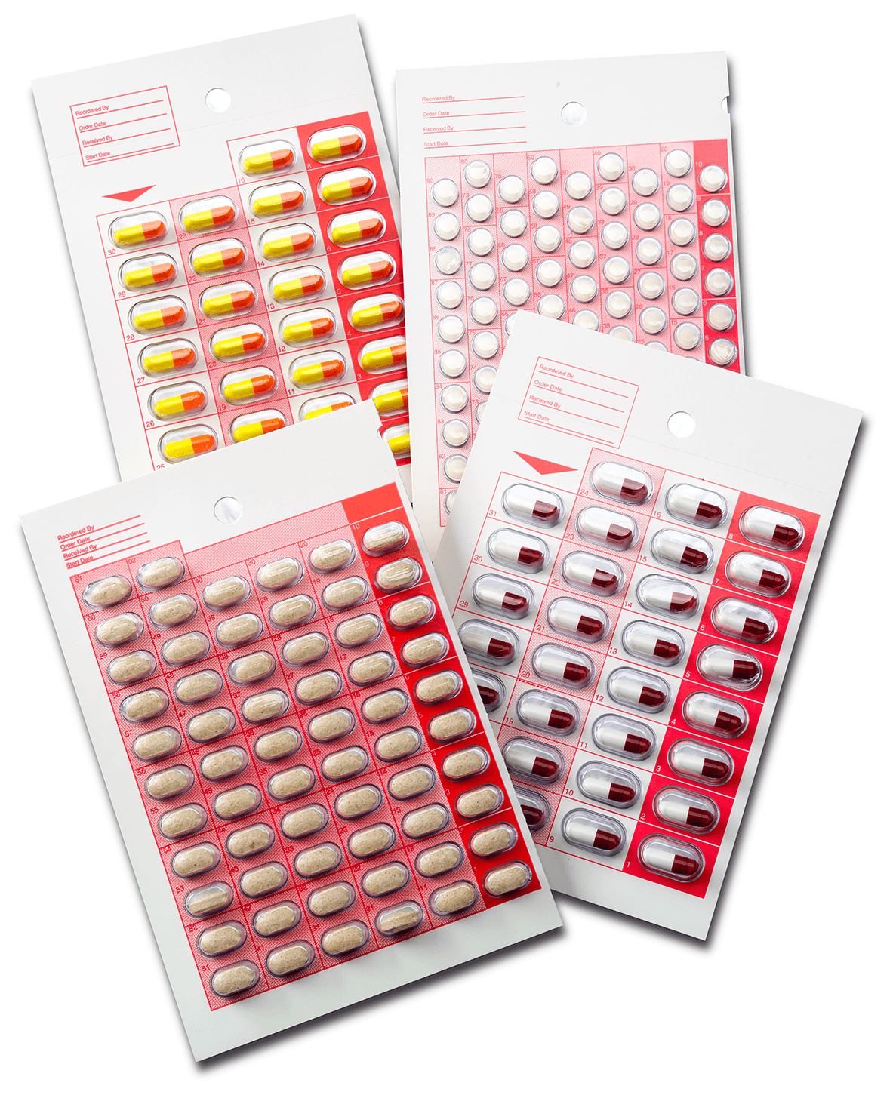
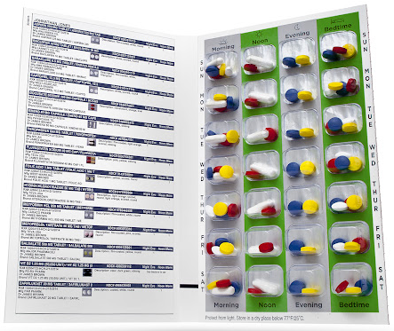
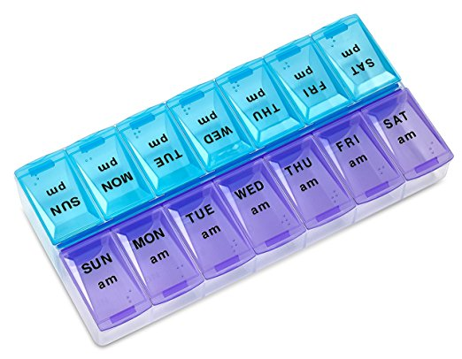
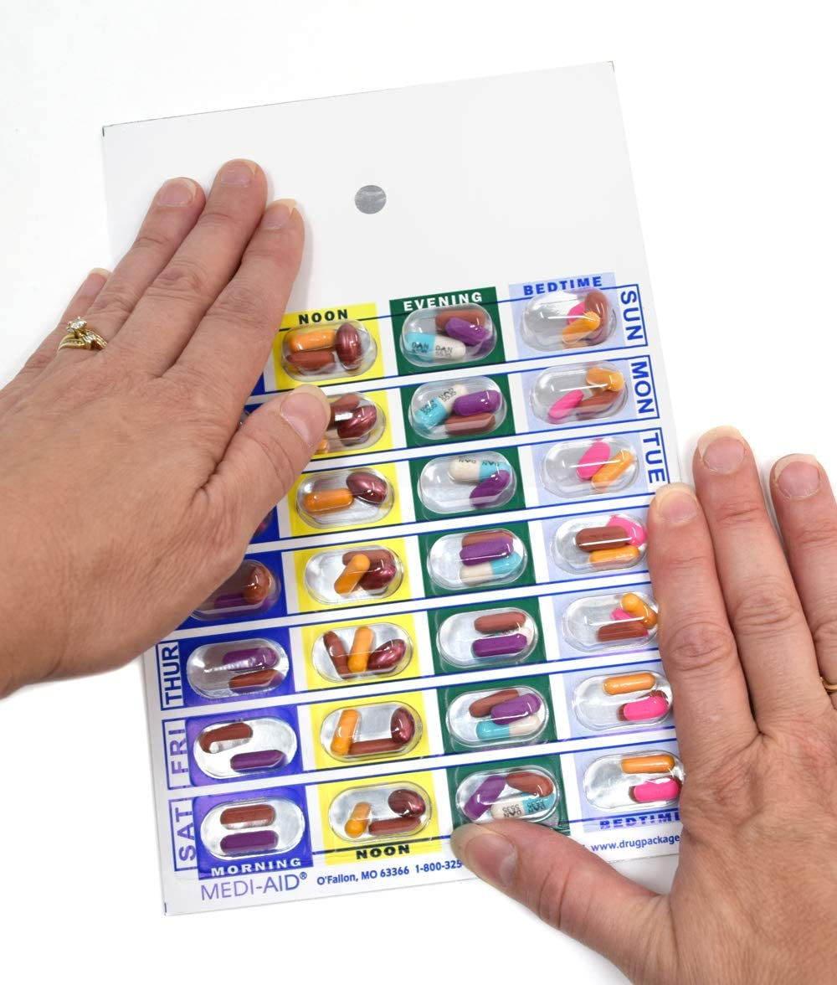
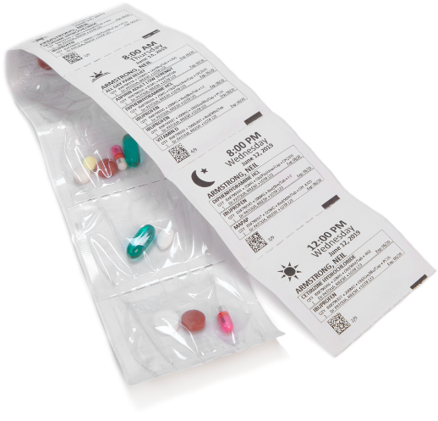
Not accepted. Not tamper-evident.
Not accepted. Not organized by day and delivery time.
Blister pack medication prepared at home by parent/guardian.

